CASE STUDY
How Well We Understand Customer Business and Delivered Fruitful Results

Case Study – 2
Successfully Developed Business on Newly Launched Amazon.ae
- Customer Name: Navin
- Account Name: Mahmayi
- Business Type: Distributor
- Client Requirements: Account Management/Sales Boost
- Our Goal: Providing Favourable Results

CLIENT EXPECTATIONS:
This client came to us for migration of his account and listing from UAE based Sooq marketplace to newly launched Amazon.ae his expected that we should list his all the inventory to AE and manage his Amazon.ae Account for Listing, Optimization, Sales Boost, PPC, Brand Registry, Infringement, Escalations EBC etc.
OUR SOLUTION:
For giving the best solution to our client and comprehensive support is our speciality which we successfully deliver with the help of our experience team, who is expertise in solving the client queries and give the best result with efficiency.
Migrating the listing from the Sooq to Amazon.ae with enhanced optimization in short time of the period and boosting sales was challenging for us, as in UAE there where few marketplaces and Amazon was a new marketplace which launched in May 1, 2019 UAE customers was new on this marketplace with totally new buying experience, but our strategy to direct target the audience who needs the products, we did the best categorization of the products as per the customers needs, in short time of the periods we worked on the utilization of the time to deliver best optimization and conversion.
OVERVIEW OF SELLER ACCOUNT:
- Find out the most important areas where our team required utmost attention to showcase the work from day one
- Understand the products, its content and images
- Understand the inventory and pricing scenarios
- Understand previous and existing marketing strategies
- Understanding customer requirement for the products
HOW IT BEGINS:
- Begins with day to day communication
- Optimized existed content by matching with amazon standards
- Enhanced images quality with the help of Tech2Globe photo editors’ team
- Added advantage of products already having buy box winner gives us kick start to planned and make successful roadmap for sale by creating Amazon Sponsored Ads
- Understanding customer requirement for the products and how well we can assist them to re-purchase from same seller
- Most relevant meta description, search terms & keywords
- Quick response on the new received orders for scheduling the order one time
- Participating in new Amazon services e.g. FBA, Prime etc.
- Focused on organic sales
- Run the ads for the consist selling products
- Best strategy PPC and tracking on daily basis
THE RESULTS:
Only scores and sales trend can show how well we have understood customer business and able to provide fruitful results. So, in case of MAHMAYI result tells everything:
Sr. No. | 5 Months Record | Monthly Record | Total Sold Units | Sales
1 | 1st Month | May | 46 | AED24834
2 | 2nd Month | June | 112 | AED45415
3 | 3rd Month | July | 79 | AED34734
4 | 4th Month | August | 175 | AED74196.47
5 | 6th Month | September | 236 | AED77786.28

It really motivates us that how well and successfully we able to develop his business in just initial 5 months which can be seen in above report, where we started with AED24834 and increased to AED77786.28

Some images of SALES REPORT for you guys to see how well we have taken customer business up and still we are on the same track:

When Joined TECH2GLOBE
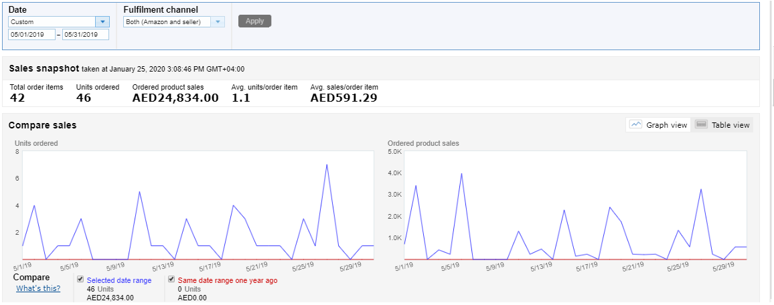
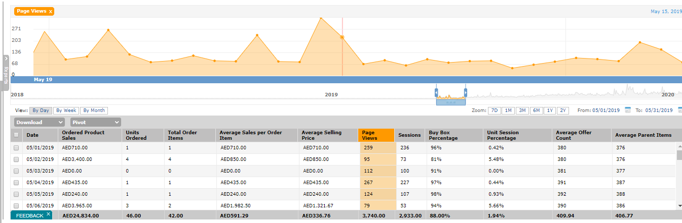
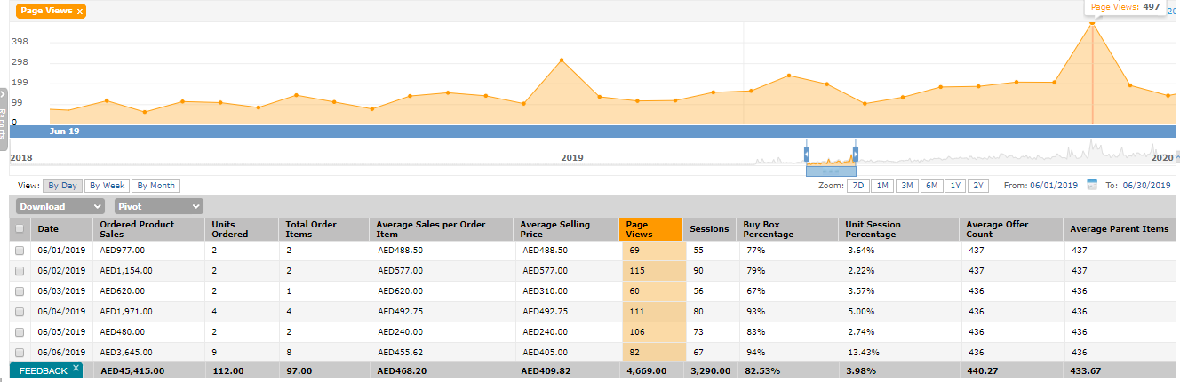
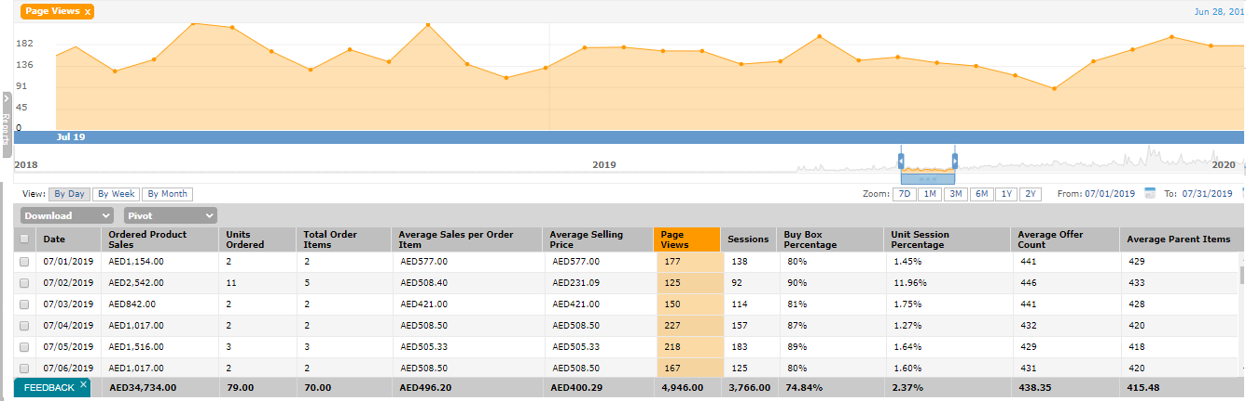
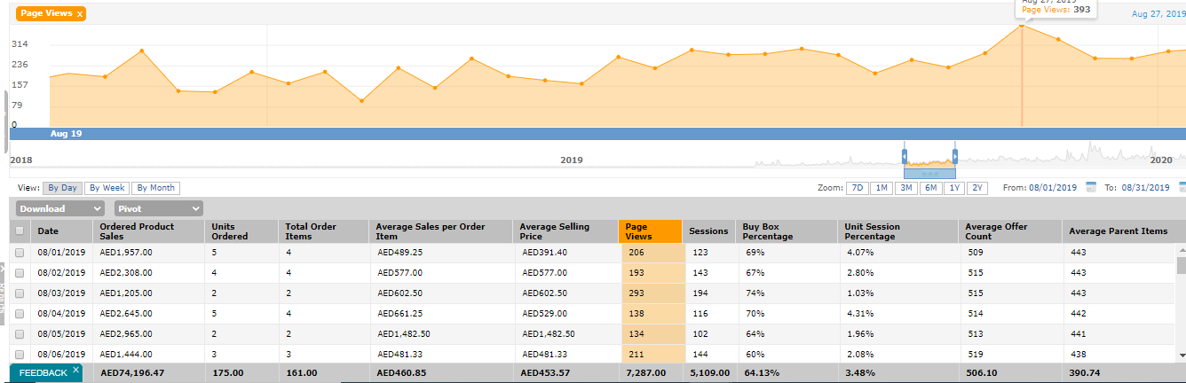

AFTER 4 Months TECH2GLOBE
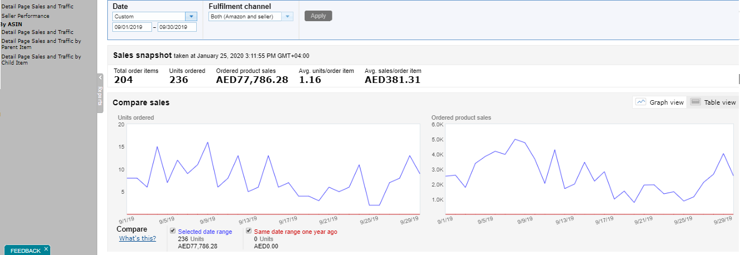
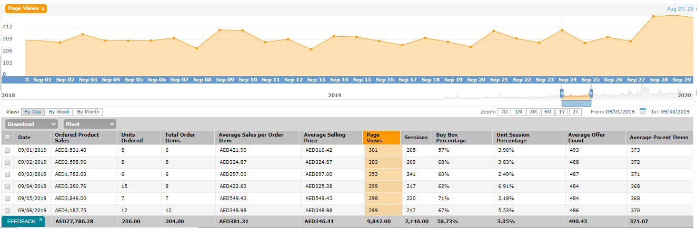
OTHER ACHIEVEMENTS:
- Feedback Rating
As you all know that good seller rating is how much important for every seller! As It always help to boost the sales and get the customer trust against the seller and customer confidently buy the products from the sellers who has good seller rating, and here for this client we helped him to get the good customers review and seller rating which can be seen in below image, as we help him to get the Feedback Rating 0 to 4.9

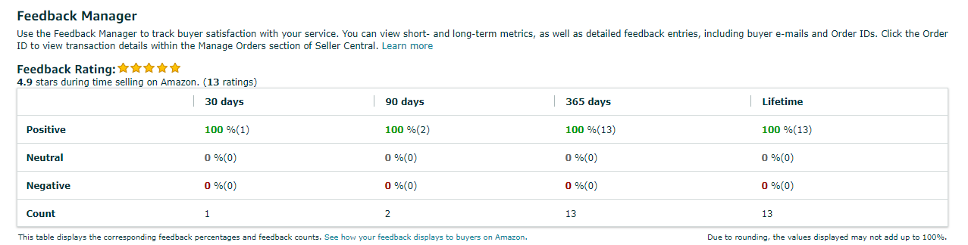
- Successful Infringement Cases

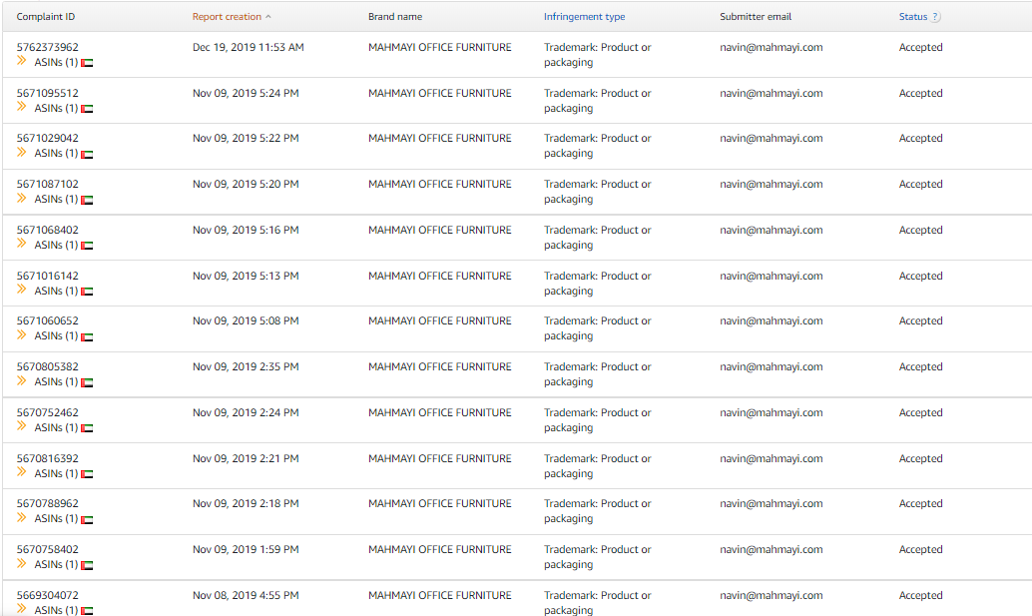
- Successful Brand Registry

